PLUGGING INTO THE FUTURE:

AN EXPLORATION OF ELECTRICITY CONSUMPTION PATTERNS

PROJECT REPORT

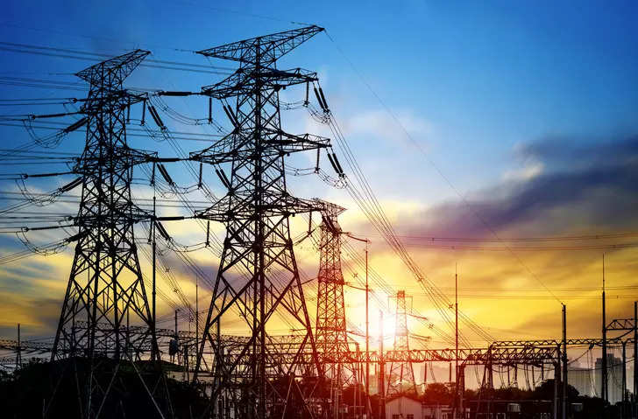

1.Introdution

* 1. Overview

India is the world's third-largest producer and third-largest consumer of electricity. The national electric grid in India has an installed capacity of 370.106 GW as of 31 March 2020. Renewable power plants, which also include large hydroelectric plants, constitute 35.86% of India's total installed capacity. During the fiscal year (FY) 2019–20, the total electricity generation in the country was 1,598 TWh, of which 1,383.5 TWh generated by utilities. The gross electricity consumption per capita in FY2019 was 1208 kWh.

Tableau allows users to create interactive dashboards and visualizations, which can be used to explore different aspects of the electricity consumption, identify trends, and compare the performance of consumption patterns. The visualizations can be customized with various chart types, colors, and filters, making it easy to present complex data in an intuitive and easy-to-understand format.

The analysis may also involve using advanced features of Tableau, such as forecasting, clustering, and machine learning, to identify patterns and trends in the electricity consumption and predict future performance of the groups. The interactive and customizable nature of Tableau also allows for a more engaging and informative presentation of the data.

1.2 Purpose

The purpose of the analysis of electricity performance of leading digital energy with Tableau is to gain insights into the energy consumption of different current and to provide stakeholders with a comprehensive and visually engaging view of their performance. The analysis aims to help investors, regulators, and other stakeholders make informed decisions about the electricity and to ensure the long-term success and stability of the electric power industry.

By using Tableau, the analysis can provide a detailed and customizable view of the electricity consumption , allowing users to explore different aspects of the data and identify patterns, trends, and outliers. This can help stakeholders to identify areas of strength and weakness, understand the risks and opportunities associated with the banks, and make informed decisions about investments, regulatory policies, and other strategic decisions. The analysis of battery performance of leading factories with Tableau can also provide insights into the broader trends and challenges facing the energy industry. By comparing the performance of different eletric power , stakeholders can identify common challenges and opportunities and development strategies to address them.

2. Problem definition & Design thinking

2.1 Empathy map

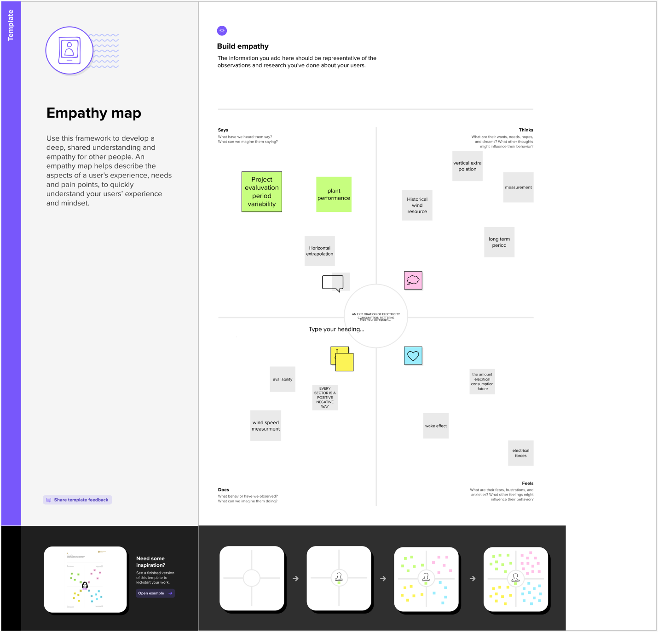

2.1 Brainstorming and Ideation Map

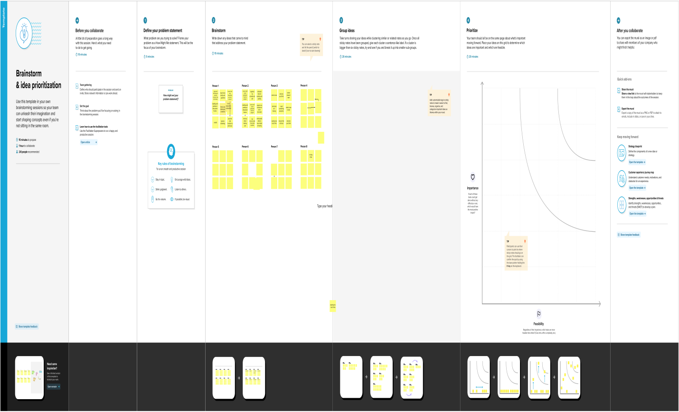

3. Result

# Analysis on Electricity Consumption In India

## India is the third largest producer of electricity in the world. During the fiscal year (FY) 2019–20, the total electricity generation in the country was 1,598 TWh, of which 1,383.5 TWh generated by utilities. The gross electricity consumption per capita in FY2019 was 1,208 kWh.

Get Started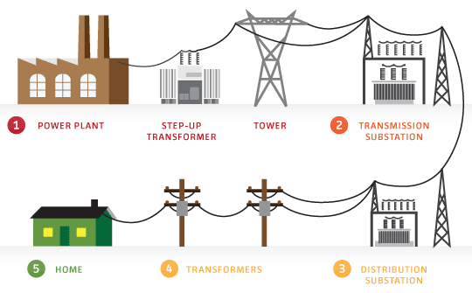

**ABOUT US**

Electric energy consumption is energy consumption in the form of electrical energy. About a fifth of global energy is consumed as electricity: for residential, industrial, commercial, transportation and other purposes.

Heating and cooling are by far the greatest energy users in the home, making up around 40% of your electric bill. Other big users are washers, dryers, ovens, and stoves. Electronic devices like laptops and TVs are usually pretty cheap to run, but of course, it can all add up.

Global electricity consumption has continued to go up rapidly at a rate faster than energy consumption. Between 1980 and 2013, the world’s annual electricity consumption rose from 7300 TWh to 22,100 TWh. Since the twenty first century, global electricity consumption has seen even faster growth, as evidenced by an average annual increase of 3.4%, 1.2 percentage points higher than average annual growth of energy consumption.

Annual electricity consumption per capita serves as an important measure of a country's electric power development. Generally speaking, electricity consumption grows faster when the industrialization process develops quickly and goes down rapidly when industrialization is completed or near completion.

Global electricity consumption, which had contracted by 0.7% in 2020 due to the COVID-19 crisis, grew by +5.5% in 2021, +4.8% above its 2019 level. In China, the largest electricity consumer with 31% of global electricity consumption, power consumption rose by nearly 10%, exceeding its 2010-2019 trend (+7.3%/year) and its 2019 level, triggered by the economic recovery.

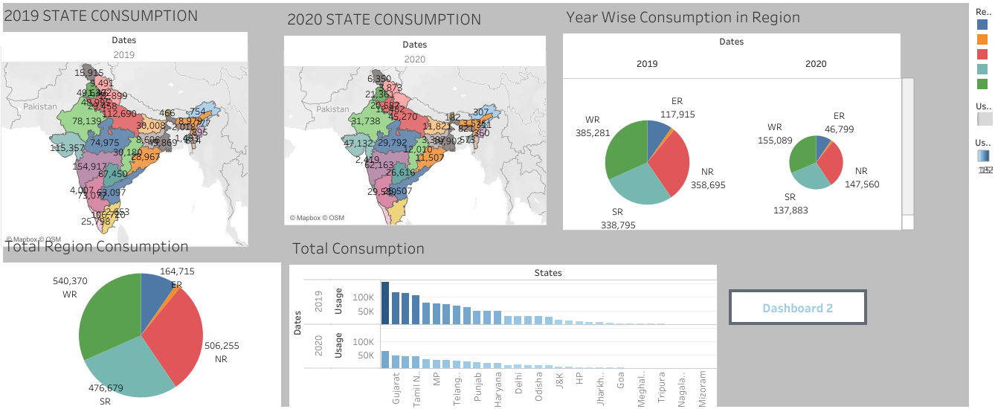

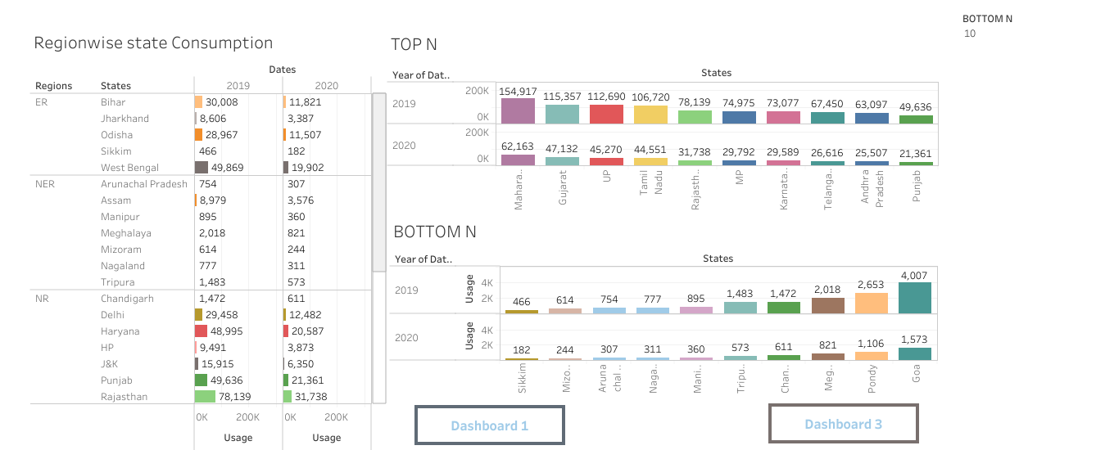

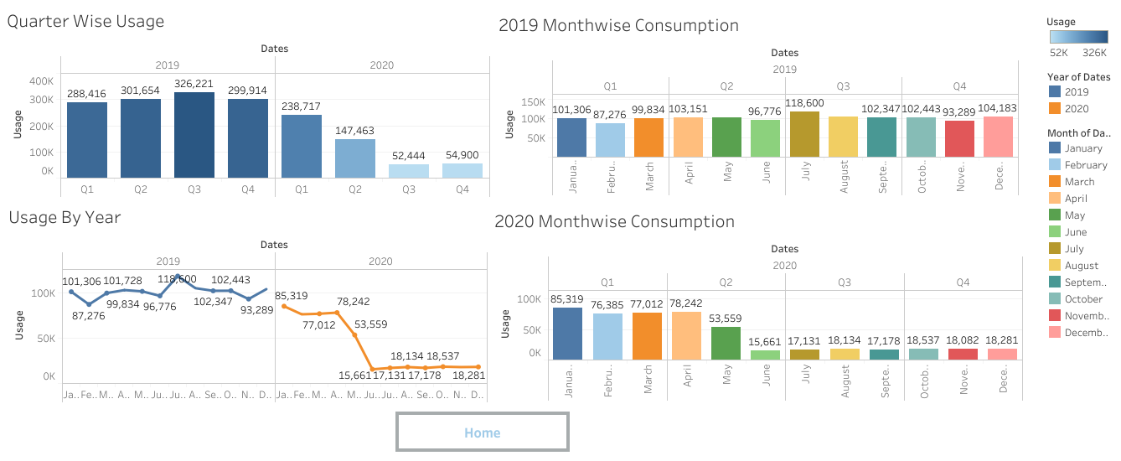

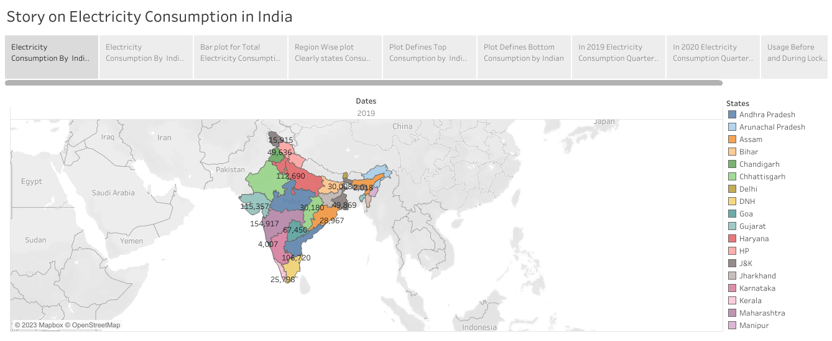

Visualization

REPORT

**Electricity Consumption Stats.**

* Maharashtra is the Highest Electricity consumption user of India.
* Gujarat is the Second Highest Electricity consumption user of India.
* Sikkim is the Lowest Electricity Consumption user of India

**Electricity Consumption before and during Lockdown in India**

Electricity consumption was more in 2019 in month of March-June before Lockdown

Electricity Consumption was less in 2020 in month of March-June during the Lockdown

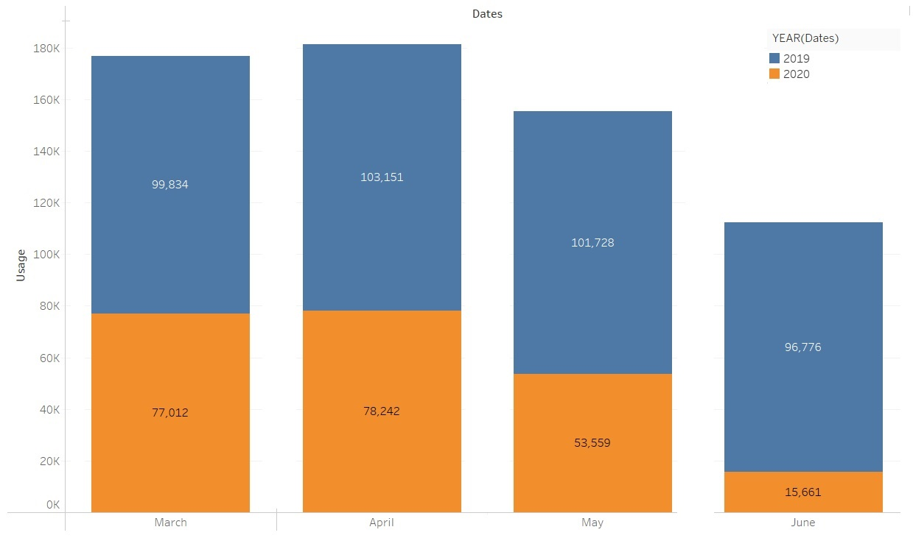

**Electricity Consumption in Quarters**

* Electricity Consumption in 2019 for Quarter 3 was Highest.
* Electricity Consumption in 2019 for Quarter 1 was Lowest.
* Electricity Consumption in 2020 for Quarter 3 was Lowest.
* Electricity Consumption in 2020 for Quarter 1 was Highest.

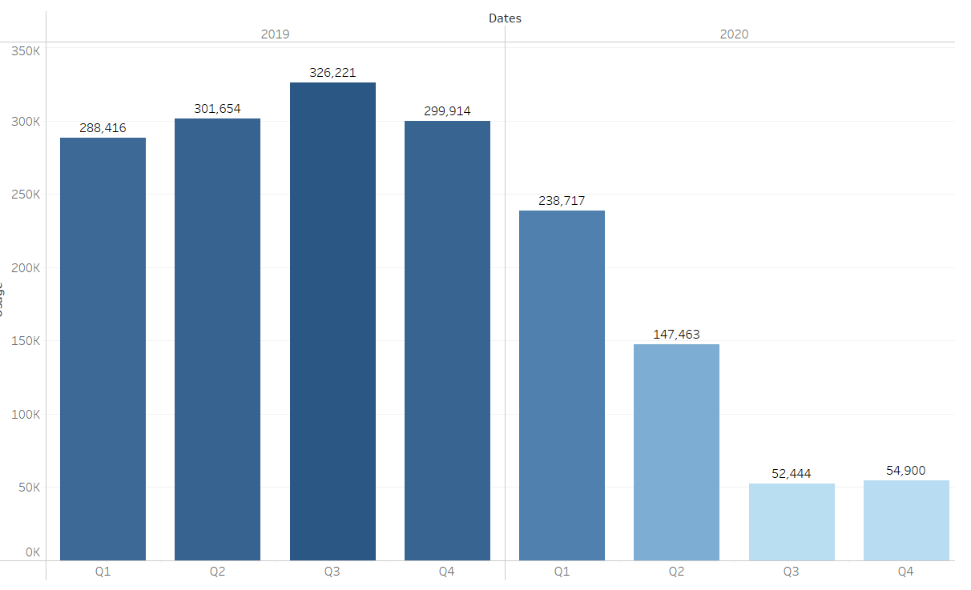

**Electricity Consumption in Regions**

* Total Electricity consumption in Western Region is Highest.
* Total Electricity consumption in North Eastern Region is Lowest.
* Electricity Consumption in 2020 for Quarter 3 was Lowest.
* Electricity Consumption in 2020 for Quarter 1 was Highest.

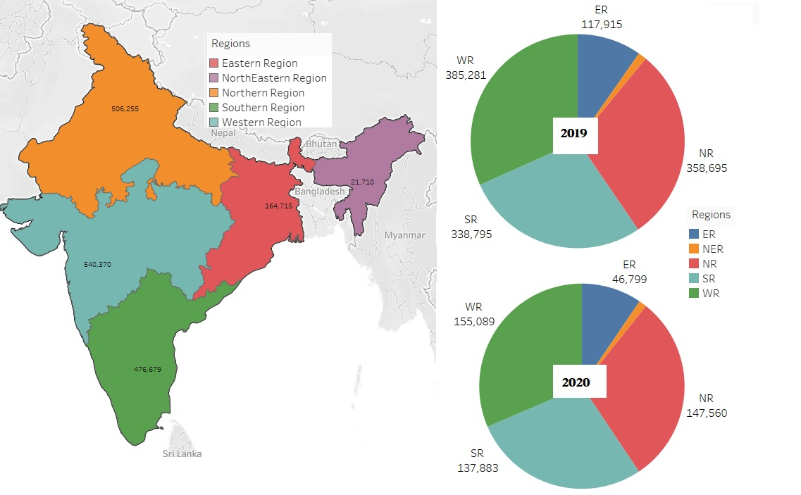



**4.Advantage & Disadvantages**

**4.1 Advantages of electricity :**

* It is a clean, safe, cheap and convenient source of energy
* Lower maintenance cost
* More efficient
* No tailpipe emission
* We all know that it  can be set up in many sizes
* It doesn't require as many employees
* Reduces greenhouse emission
* Makes barely any pollution compare to other ways of creating or generating electricity
* Relatively low maintenance cost
* Hydroelectric station are inexpensive to operate
* Hydroelectricity produces no gas emissions or waste
* A station can operate and run for long periods of time
* It is renewable

**Disadvantages of electricity :**

* More expensive than gasoline
* Loss of fish species
* Sometimes messes up wildlife
* Dependent on precipitation
* More power plants and more pollution
* Damming can cause loss of land suitable for agriculture as well as recreation
* Cost for construction
* Change in river or stream quality
* An electric vehicle is not completely emission free
* In electricity, there are a limited number of feasible sites for a large number of dams
* Drought can affect power production
* Hydroelectric natural seasonal changes in river and ecosystems can be destroyed

5. Applications

Electricity is an essential part of modern life and important to the U.S. economy. People use electricity for lighting, heating, cooling, and refrigeration and for operating appliances, computers, electronics, machinery, and public transportation systems. Total U.S. electricity consumption in 2022 was about 4.05 trillion kWh, the highest amount recorded and 14 times greater than electricity use in 1950. Total annual U.S. electricity consumption increased in all but 11 years between 1950 and 2022, and 8 of the years with year-over-year decreases occurred after 2007.

## Heating and cooling are the largest residential electricity uses

Heating and cooling (air conditioning) account for the largest annual uses of electricity in the [residential sector](https://www.eia.gov/tools/glossary/index.php?id=Residential%20sector). Because these uses are mainly weather related, the amounts and their shares of total annual residential electricity consumption vary from year to year. The [Residential Energy Consumption Survey](https://www.eia.gov/consumption/residential) (RECS) data for 2015 indicate that heating was the largest [use of electricity in homes](https://www.eia.gov/energyexplained/use-of-energy/electricity-use-in-homes.php). The [Annual Energy Outlook](https://www.eia.gov/outlooks/aeo/) (AEO) provides estimates and projections for annual electricity use in the residential sector by type of end use.

## Electricity use in the United States is projected to grow slowly

Although near-term U.S. electricity demand may fluctuate as a result of year-to-year changes in weather, trends in long-term demand tend to be driven by economic growth offset by increases in energy end-use efficiency. In the AEO2023 Reference case, the annual growth in total U.S. electricity demand is projected to average about 1% from 2022 through 2050.

# The Top 5 Biggest Users Of Electricity In Your Home

* 1. **Air Conditioning & Heating**
  2. **Water Heating**
  3. **Appliances**
  4. **Lighting**
  5. **Television and Media Equipment**

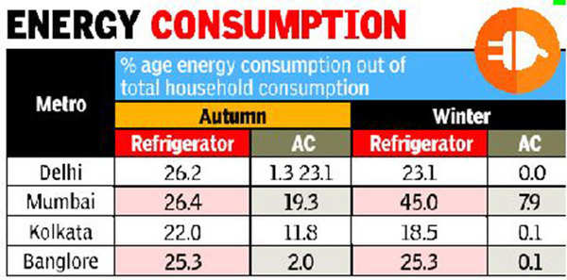

**6.Conclusion**

Electricity is the backbone of modern society. Our life will go back to the primitive age without of electricity. There is a need for rational use of electricity, as it is largely produced from non-renewable source like coal and water. Alternative source of electricity should be explored to meet the gape between its demand and supply. We should take every step to conserve sources of electricity for future generations.

* 2019 State Consumption
* 2020 State Consumption
* Total Consumption
* Usage by Region
* Top N and Bottom N
* 2019 and 2020 Monthwise Consumption
* Total Consumption Region Wise
* Usage Before and After Consumption
* Region wise State Usage
* Quarter Usage
* Metro city State Usage
* Usage by year
* Story on Electricity Consumption In India

The discovery of electricity was a turning point of history because without it we would not live in the world that we live in today which is filled with life changing technology but it all needs and uses electricity. Without  electricity you would not be able to view this page or be on a computer at this very moment. Electricity is something that we all live by whether we notice it or not, some of us would not be able to survive without it because it is a must needed source to our everyday lives. It is used to help save people, in education, hospitals, cities, etc., we live by this incredible creation that mother nature has given us and we have been able to control it with our very own hands throughout centuries. Especially in this crazy changing world where things are being invented and created everyday, it would not be possible without "Electricity".

.

7.Future scope

By analyzing the data set we can make an aware of electricity consumption among people. People think of long-term effect such as health hazards due to the consumption. We can stand along with India’s cabinet updated climate plan, including a 2070 net consumption intensity by 2030. Sustainable heating current electricity. Public transportation or carpool can be encouraged. Usage of alternative sources of energy instead of fossil fuels. Reduce the consumption gives a sustainable society.

8. Appendix

8.1 HTML code for the output web page

<!DOCTYPE html>

<html lang="en">

<head>

    <meta charset="utf-8">

    <meta content="width=device-width, initial-scale=1.0" name="viewport">

    <title>Fin Anlytics /title>

    <meta content="" name="description">

    <meta content="" name="keywords">

    <!-- Favicons -->

    <link href="assets/img/favicon.png" rel="icon">

    <link href="assets/img/apple-touch-icon.png" rel="apple-touch-icon">

    <!-- Google Fonts -->

    <link href="https://fonts.googleapis.com/css?family=Open+Sans:300,300i,400,400i,600,600i,700,700i|Jost:300,300i,400,400i,500,500i,600,600i,700,700i|Poppins:300,300i,400,400i,500,500i,600,600i,700,700i" rel="stylesheet">

    <!-- Vendor CSS Files -->

    <link href="assets/vendor/aos/aos.css" rel="stylesheet">

    <link href="assets/vendor/bootstrap/css/bootstrap.min.css" rel="stylesheet">

    <link href="assets/vendor/bootstrap-icons/bootstrap-icons.css" rel="stylesheet">

    <link href="assets/vendor/boxicons/css/boxicons.min.css" rel="stylesheet">

    <link href="assets/vendor/glightbox/css/glightbox.min.css" rel="stylesheet">

    <link href="assets/vendor/remixicon/remixicon.css" rel="stylesheet">

    <link href="assets/vendor/swiper/swiper-bundle.min.css" rel="stylesheet">

    <!-- Template Main CSS File -->

    <link href="assets/css/style.css" rel="stylesheet">

    <!-- =======================================================

  * Template Name: Arsha - v4.10.0

  * Template URL: https://bootstrapmade.com/arsha-free-bootstrap-html-template-corporate/

  * Author: BootstrapMade.com

  * License: https://bootstrapmade.com/license/

  ======================================================== -->

</head>

<body>

    <!-- ======= Header ======= -->

    <header id="header" class="fixed-top ">

        <div class="container d-flex align-items-center justify-content-between">

            <h1 class="logo"><img src="https://media.istockphoto.com/id/1323550608/vector/co2-reduction-cloud-eco-vector-icon.jpg?s=612x612&w=0&k=20&c=jO3OZfYAg9gB8TWvzH8BR64Lq3pFrfHcOvxpSgB-cjA="> </h1>

            <!-- Uncomment below if you prefer to use an image logo -->

            <!-- <a href="index.html" class="logo me-auto"><img src="assets/img/logo.png" alt="" class="img-fluid"></a>-->

            <nav id="navbar" class="navbar">

                <ul>

                    <li><a class="nav-link scrollto active" href="#hero">Home</a></li>

                    <li><a class="nav-link scrollto" href="#about">About</a></li>

                    <li><a class="nav-link scrollto" href="#dash">Dashboard</a></li>

                    <li><a class="nav-link scrollto" href="#services">Story</a></li>

                    <li><a class="nav-link scrollto" href="#portfolio">Visualizations</a></li>

                    <li><a class="nav-link scrollto" href="#report">Report</a></li>

                    <li><a class="nav-link scrollto" href="#contact">Contact</a></li>

                </ul>

                <i class="bi bi-list mobile-nav-toggle"></i>

            </nav>

            <!-- .navbar -->

        </div>

    </header>

    <!-- End Header -->

    <!-- ======= Hero Section ======= -->

    <section id="hero" class="d-flex align-items-center">

        <div class="container">

            <div class="row">

                <div class="col-lg-6 d-flex flex-column justify-content-center pt-4 pt-lg-0 order-2 order-lg-1" data-aos="fade-up" data-aos-delay="200">

                    <h1>Welcome to Global Co2 Emission Analysis for Year 2020</h1>

                    <h2>Carbon dioxide emissions are the primary driver of global climate change. It’s widely recognised that to avoid the worst impacts of climate change, the world needs to urgently reduce emissions.</h2>

                    <div class="d-flex justify-content-center justify-content-lg-start">

                        <a href="#about" class="btn-get-started scrollto">Get Started</a>

                        <a href="https://www.youtube.com/watch?v=jDDaplaOz7Q" class="glightbox btn-watch-video"></a>

                    </div>

                </div>

                <div class="col-lg-6 order-1 order-lg-2 hero-img" data-aos="zoom-in" data-aos-delay="200">

                    <img src="https://www.treehugger.com/thmb/LbdMV9gbfA1S7Y3SB0XhlSl4EFw=/1500x0/filters:no_upscale():max_bytes(150000):strip_icc()/co-why-is-carbon-dioxide-bad-4864246_V2-4ea7c0936b5a4cd3b8d4f2b41ec02f63.png" class="img-fluid animated" alt="">

                </div>

            </div>

        </div>

    </section>

    <!-- End Hero -->

    <main id="main">

        <!-- ======= Clients Section ======= -->

        <!-- End Cliens Section -->

        <!-- ======= About Us Section ======= -->

        <section id="about" class="about">

            <div class="container">

                <div class="section-title">

                    <h2>About Us</h2>

                </div>

                <div class="row content">

                    <div class="col-lg-12">

                        <p>

                            Carbon dioxide emissions are those stemming from the burning of fossil fuels and the manufacture of cement. They include carbon dioxide produced during consumption of solid, liquid, and gas fuels and gas flaring.

                        </p>

                        <p>

                            Global carbon dioxide (CO2) emissions from fossil fuels and industry have increased considerably since 2000, and in 2019 reached a record high of 36.7 billion metric tons of CO2. In 2020, the COVID-19 pandemic caused global CO2 emissions to plummet five

                            percent to 34.81 billion metric tons.</p>

                        <p> Historically, major global events cause emission reductions. The 2009 global recession caused worldwide CO2 emissions to fall by approximately 460 million metric tons. But this pales in comparison to the emission reductions in

                            2020. Countries around the world were put under strict lockdowns, meaning transportation and industrial activities were significantly reduced. CO2 emission levels in India dropped for the first time in four decades in the year

                            ending March 2020. Global CO2 emissions per capita also experienced a substantial decline in 2020, falling to an average of 4.47 metric tons per person.</p>

                    </div>

                </div>

            </div>

        </section>

        <!-- End About Us Section -->

        <!-- ======= Why Us Section ======= -->

        <section id="dash" class="">

            <div class="container-fluid" data-aos="fade-up">

                <div class="section-title">

                    <h2>Dashboard</h2>

                <div class='tableauPlaceholder' id='viz1682312095428' style='position: relative'><noscript><a href='#'><img alt='Dashboard 1 ' src='https:&#47;&#47;public.tableau.com&#47;static&#47;images&#47;AG&#47;AGlobalCO2EmissionAnalysis&#47;Dashboard1&#47;1_rss.png' style='border: none' /></a></noscript><object class='tableauViz'  style='display:none;'><param name='host_url' value='https%3A%2F%2Fpublic.tableau.com%2F' /> <param name='embed_code_version' value='3' /> <param name='site_root' value='' /><param name='name' value='AGlobalCO2EmissionAnalysis&#47;Dashboard1' /><param name='tabs' value='no' /><param name='toolbar' value='yes' /><param name='static_image' value='https:&#47;&#47;public.tableau.com&#47;static&#47;images&#47;AG&#47;AGlobalCO2EmissionAnalysis&#47;Dashboard1&#47;1.png' /> <param name='animate_transition' value='yes' /><param name='display_static_image' value='yes' /><param name='display_spinner' value='yes' /><param name='display_overlay' value='yes' /><param name='display_count' value='yes' /><param name='language' value='en-US' /><param name='filter' value='publish=yes' /></object></div>                <script type='text/javascript'>                    var divElement = document.getElementById('viz1682312095428');                    var vizElement = divElement.getElementsByTagName('object')[0];                    if ( divElement.offsetWidth > 800 ) { vizElement.style.width='1000px';vizElement.style.height='827px';} else if ( divElement.offsetWidth > 500 ) { vizElement.style.width='1000px';vizElement.style.height='827px';} else { vizElement.style.width='100%';vizElement.style.height='1327px';}                     var scriptElement = document.createElement('script');                    scriptElement.src = 'https://public.tableau.com/javascripts/api/viz_v1.js';                    vizElement.parentNode.insertBefore(scriptElement, vizElement);                </script>

                <div class='tableauPlaceholder' id='viz1682313927332' style='position: relative'><noscript><a href='#'><img alt='Dashboard 2 ' src='https:&#47;&#47;public.tableau.com&#47;static&#47;images&#47;AG&#47;AGlobalCO2EmissionAnalysis-1&#47;Dashboard2&#47;1_rss.png' style='border: none' /></a></noscript><object class='tableauViz'  style='display:none;'><param name='host_url' value='https%3A%2F%2Fpublic.tableau.com%2F' /> <param name='embed_code_version' value='3' /> <param name='site_root' value='' /><param name='name' value='AGlobalCO2EmissionAnalysis-1&#47;Dashboard2' /><param name='tabs' value='no' /><param name='toolbar' value='yes' /><param name='static_image' value='https:&#47;&#47;public.tableau.com&#47;static&#47;images&#47;AG&#47;AGlobalCO2EmissionAnalysis-1&#47;Dashboard2&#47;1.png' /> <param name='animate_transition' value='yes' /><param name='display_static_image' value='yes' /><param name='display_spinner' value='yes' /><param name='display_overlay' value='yes' /><param name='display_count' value='yes' /><param name='language' value='en-US' /><param name='filter' value='publish=yes' /></object></div>                <script type='text/javascript'>                    var divElement = document.getElementById('viz1682313927332');                    var vizElement = divElement.getElementsByTagName('object')[0];                    if ( divElement.offsetWidth > 800 ) { vizElement.style.width='1000px';vizElement.style.height='827px';} else if ( divElement.offsetWidth > 500 ) { vizElement.style.width='1000px';vizElement.style.height='827px';} else { vizElement.style.width='100%';vizElement.style.height='1127px';}                     var scriptElement = document.createElement('script');                    scriptElement.src = 'https://public.tableau.com/javascripts/api/viz_v1.js';                    vizElement.parentNode.insertBefore(scriptElement, vizElement);                </script>

                <div class='tableauPlaceholder' id='viz1682313955894' style='position: relative'><noscript><a href='#'><img alt='Dashboard 3 ' src='https:&#47;&#47;public.tableau.com&#47;static&#47;images&#47;AG&#47;AGlobalCO2EmissionAnalysis-2&#47;Dashboard3&#47;1_rss.png' style='border: none' /></a></noscript><object class='tableauViz'  style='display:none;'><param name='host_url' value='https%3A%2F%2Fpublic.tableau.com%2F' /> <param name='embed_code_version' value='3' /> <param name='site_root' value='' /><param name='name' value='AGlobalCO2EmissionAnalysis-2&#47;Dashboard3' /><param name='tabs' value='no' /><param name='toolbar' value='yes' /><param name='static_image' value='https:&#47;&#47;public.tableau.com&#47;static&#47;images&#47;AG&#47;AGlobalCO2EmissionAnalysis-2&#47;Dashboard3&#47;1.png' /> <param name='animate_transition' value='yes' /><param name='display_static_image' value='yes' /><param name='display_spinner' value='yes' /><param name='display_overlay' value='yes' /><param name='display_count' value='yes' /><param name='language' value='en-US' /><param name='filter' value='publish=yes' /></object></div>                <script type='text/javascript'>                    var divElement = document.getElementById('viz1682313955894');                    var vizElement = divElement.getElementsByTagName('object')[0];                    if ( divElement.offsetWidth > 800 ) { vizElement.style.width='1000px';vizElement.style.height='827px';} else if ( divElement.offsetWidth > 500 ) { vizElement.style.width='1000px';vizElement.style.height='827px';} else { vizElement.style.width='100%';vizElement.style.height='1177px';}                     var scriptElement = document.createElement('script');                    scriptElement.src = 'https://public.tableau.com/javascripts/api/viz_v1.js';                    vizElement.parentNode.insertBefore(scriptElement, vizElement);                </script>

                <div class='tableauPlaceholder' id='viz1682314008975' style='position: relative'><noscript><a href='#'><img alt='Dashboard 4 ' src='https:&#47;&#47;public.tableau.com&#47;static&#47;images&#47;AG&#47;AGlobalCO2EmissionAnalysis-3&#47;Dashboard4&#47;1_rss.png' style='border: none' /></a></noscript><object class='tableauViz'  style='display:none;'><param name='host_url' value='https%3A%2F%2Fpublic.tableau.com%2F' /> <param name='embed_code_version' value='3' /> <param name='site_root' value='' /><param name='name' value='AGlobalCO2EmissionAnalysis-3&#47;Dashboard4' /><param name='tabs' value='no' /><param name='toolbar' value='yes' /><param name='static_image' value='https:&#47;&#47;public.tableau.com&#47;static&#47;images&#47;AG&#47;AGlobalCO2EmissionAnalysis-3&#47;Dashboard4&#47;1.png' /> <param name='animate_transition' value='yes' /><param name='display_static_image' value='yes' /><param name='display_spinner' value='yes' /><param name='display_overlay' value='yes' /><param name='display_count' value='yes' /><param name='language' value='en-US' /><param name='filter' value='publish=yes' /></object></div>                <script type='text/javascript'>                    var divElement = document.getElementById('viz1682314008975');                    var vizElement = divElement.getElementsByTagName('object')[0];                    if ( divElement.offsetWidth > 800 ) { vizElement.style.width='1000px';vizElement.style.height='827px';} else if ( divElement.offsetWidth > 500 ) { vizElement.style.width='1000px';vizElement.style.height='827px';} else { vizElement.style.width='100%';vizElement.style.height='1477px';}                     var scriptElement = document.createElement('script');                    scriptElement.src = 'https://public.tableau.com/javascripts/api/viz_v1.js';                    vizElement.parentNode.insertBefore(scriptElement, vizElement);                </script>

                <div class='tableauPlaceholder' id='viz1682314031832' style='position: relative'><noscript><a href='#'><img alt='Dashboard 5 ' src='https:&#47;&#47;public.tableau.com&#47;static&#47;images&#47;AG&#47;AGlobalCO2EmissionAnalysis-4&#47;Dashboard5&#47;1_rss.png' style='border: none' /></a></noscript><object class='tableauViz'  style='display:none;'><param name='host_url' value='https%3A%2F%2Fpublic.tableau.com%2F' /> <param name='embed_code_version' value='3' /> <param name='site_root' value='' /><param name='name' value='AGlobalCO2EmissionAnalysis-4&#47;Dashboard5' /><param name='tabs' value='no' /><param name='toolbar' value='yes' /><param name='static_image' value='https:&#47;&#47;public.tableau.com&#47;static&#47;images&#47;AG&#47;AGlobalCO2EmissionAnalysis-4&#47;Dashboard5&#47;1.png' /> <param name='animate_transition' value='yes' /><param name='display_static_image' value='yes' /><param name='display_spinner' value='yes' /><param name='display_overlay' value='yes' /><param name='display_count' value='yes' /><param name='language' value='en-US' /><param name='filter' value='publish=yes' /></object></div>                <script type='text/javascript'>                    var divElement = document.getElementById('viz1682314031832');                    var vizElement = divElement.getElementsByTagName('object')[0];                    if ( divElement.offsetWidth > 800 ) { vizElement.style.width='1000px';vizElement.style.height='827px';} else if ( divElement.offsetWidth > 500 ) { vizElement.style.width='1000px';vizElement.style.height='827px';} else { vizElement.style.width='100%';vizElement.style.height='1227px';}                     var scriptElement = document.createElement('script');                    scriptElement.src = 'https://public.tableau.com/javascripts/api/viz_v1.js';                    vizElement.parentNode.insertBefore(scriptElement, vizElement);                </script>

            <!-- ======= Skills Section ======= -->

            <!-- End Skills Section -->

            <!-- End Services Section -->

            <!-- ======= Cta Section ======= -->

            <!-- End Cta Section -->

            <!-- ======= Portfolio Section ======= -->

            <section id="portfolio" class="portfolio">

                <div class="container" data-aos="fade-up">

                    <div class="section-title">

                        <h2>Visualizations</h2>

                        <div class='tableauPlaceholder' id='viz1682314345990' style='position: relative'><noscript><a href='#'><img alt='Story on Global CO2 Emission Analysis ' src='https:&#47;&#47;public.tableau.com&#47;static&#47;images&#47;AG&#47;AGlobalCO2EmissionAnalysis-Story&#47;Story1&#47;1_rss.png' style='border: none' /></a></noscript><object class='tableauViz'  style='display:none;'><param name='host_url' value='https%3A%2F%2Fpublic.tableau.com%2F' /> <param name='embed_code_version' value='3' /> <param name='site_root' value='' /><param name='name' value='AGlobalCO2EmissionAnalysis-Story&#47;Story1' /><param name='tabs' value='no' /><param name='toolbar' value='yes' /><param name='static_image' value='https:&#47;&#47;public.tableau.com&#47;static&#47;images&#47;AG&#47;AGlobalCO2EmissionAnalysis-Story&#47;Story1&#47;1.png' /> <param name='animate_transition' value='yes' /><param name='display_static_image' value='yes' /><param name='display_spinner' value='yes' /><param name='display_overlay' value='yes' /><param name='display_count' value='yes' /><param name='language' value='en-US' /></object></div>                <script type='text/javascript'>                    var divElement = document.getElementById('viz1682314345990');                    var vizElement = divElement.getElementsByTagName('object')[0];                    vizElement.style.width='1016px';vizElement.style.height='991px';                    var scriptElement = document.createElement('script');                    scriptElement.src = 'https://public.tableau.com/javascripts/api/viz_v1.js';                    vizElement.parentNode.insertBefore(scriptElement, vizElement);                </script>

            <section id="report" class="skills">

                <div class="container" data-aos="fade-up">

                    <div class="section-title">

                        <h2>Report</h2>

                    </div>

                    <div class="row content">

                        <div class="col-md-5 order-1 order-md-2" data-aos="fade-right" data-aos-delay="100">

                            <img src="assets/img/r1.jpg" class="img-fluid" alt="">

                        </div>

                        <div class="col-lg-6 pt-4 pt-lg-0 content" data-aos="fade-left" data-aos-delay="100">

                            <h3>Top Co2 Emitting countries for Past 10 Years</h3>

                            <br>

                            <p class="fst-italic">

                                China is the highest Co2 Emitting country among the other countries.

                            </p>

                            <p class="fst-italic">

                                United States is the second highest Co2 Emitting country.

                            </p>

                            <p class="fst-italic">

                                India is the Third highest Co2 Emitting country.

                            </p>

                        </div>

                    </div>

                    <br>

                    <br>

                    <div class="row content">

                        <div class="col-md-5" data-aos="fade-right">

                            <img src="assets/img/r2.jpg" class="img-fluid" alt="">

                        </div>

                        <div class="col-md-7 pt-5" data-aos="fade-left">

                            <h3>Continents Contribution towards Co2 Emission</h3>

                            <br>

                            <p class="fst-italic">

                                Asian is the highest Co2 Emitting country among the other continents.

                            </p>

                            <p class="fst-italic">

                                Europe is the second highest Co2 Emitting continent.

                            </p>

                            <p class="fst-italic">

                                Antartica is the lowest Co2 Emitting countries because of low human activity/existence in the continent.

                            </p>

                        </div>

                        <br>

                        <br>

                        <div class="row content">

                            <div class="col-md-5" data-aos="fade-right">

                                <img src="assets/img/r3.jpg" class="img-fluid" alt="">

                            </div>

                            <div class="col-md-7 pt-5" data-aos="fade-left">

                                <h3>Overall India Contribution towards Co2 Emission</h3>

                                <br>

                                <p class="fst-italic">

                                    Coal is the highest factor of Co2 Emission.

                                </p>

                                <p class="fst-italic">

                                    Oil is the second highest Co2 Emitting factor.

                                </p>

                            </div>

                        </div>

                        <div class="row content">

                            <div class="col-md-5 order-1 order-md-2" data-aos="fade-left">

                                <img src="assets/img/r5.jpg" class="img-fluid" alt="">

                            </div>

                            <div class="col-md-7 pt-5 order-2 order-md-1" data-aos="fade-right">

                                <h3>Overall Co2 Emission over time </h3>

                                <br>

                                <p class="fst-italic">

                                    Co2 Emission in 1975 was 67324 (in metric tons).

                                </p>

                                <p class="fst-italic">

                                    Co2 Emission in 2019 was 128423 (in metric tons) which was highest in the past years.

                                </p>

                                <p class="fst-italic">

                                    Co2 Emission in 2020 was found to be 121593 (in metric tons).

                                </p>

                            </div>

                        </div>

                    </div>

                </div>

            </section>

            <!-- End Portfolio Section -->

            <!-- ======= Team Section ======= -->

            <!-- End Team Section -->

            <!-- ======= Pricing Section ======= -->

            <!-- End Pricing Section -->

            <!-- ======= Contact Section ======= -->

            <section id="contact" class="contact">

                <div class="container" data-aos="fade-up">

                    <div class="section-title">

                        <h2>Contact</h2>

                    </div>

                    <div class="row">

                        <div class="col-lg-5 d-flex align-items-stretch">

                            <div class="info">

                                <div class="address">

                                    <i class="bi bi-geo-alt"></i>

                                    <h4>Location:</h4>

                                    <p>SmartBridge, Hyderabad,AndhraPradesh, India</p>

                                </div>

                                <div class="email">

                                    <i class="bi bi-envelope"></i>

                                    <h4>Email:</h4>

                                    <p>info@smartbridge.com<br>contact@smartbridge.com</p>

                                </div>

                                <div class="phone">

                                    <i class="bi bi-phone"></i>

                                    <h4>Call:</h4>

                                    <p>+11 1234 1234<br>+11 4321 4321</p>

                                </div>

                            </div>

                        </div>

                        <div class="col-lg-7 mt-5 mt-lg-0 d-flex align-items-stretch">

                            <form action="forms/contact.php" method="post" role="form" class="php-email-form">

                                <div class="row">

                                    <div class="form-group col-md-6">

                                        <label for="name">Your Name</label>

                                        <input type="text" name="name" class="form-control" id="name" required>

                                    </div>

                                    <div class="form-group col-md-6">

                                        <label for="name">Your Email</label>

                                        <input type="email" class="form-control" name="email" id="email" required>

                                    </div>

                                </div>

                                <div class="form-group">

                                    <label for="name">Subject</label>

                                    <input type="text" class="form-control" name="subject" id="subject" required>

                                </div>

                                <div class="form-group">

                                    <label for="name">Message</label>

                                    <textarea class="form-control" name="message" rows="10" required></textarea>

                                </div>

                                <div class="my-3">

                                    <div class="loading">Loading</div>

                                    <div class="error-message"></div>

                                    <div class="sent-message">Your message has been sent. Thank you!</div>

                                </div>

                                <div class="text-center"><button type="submit">Send Message</button></div>

                            </form>

                        </div>

                    </div>

                </div>

            </section>

            <!-- End Contact Section -->

    </main>

    <!-- End #main -->

    <!-- ======= Footer ======= -->

    <footer id="footer">

        <div class="footer-top">

            <div class="container">

            </div>

        </div>

        <div class="container footer-bottom clearfix">

            <div class="copyright">

                &copy; Copyright <strong><span>Arsha</span></strong>. All Rights Reserved

            </div>

            <div class="credits">

                <!-- All the links in the footer should remain intact. -->

                <!-- You can delete the links only if you purchased the pro version. -->

                <!-- Licensing information: https://bootstrapmade.com/license/ -->

                <!-- Purchase the pro version with working PHP/AJAX contact form: https://bootstrapmade.com/arsha-free-bootstrap-html-template-corporate/ -->

                Designed by <a href="https://bootstrapmade.com/">Indra Prakash</a>

                <div class="social-links mt-3">

                    <a href="#" class="twitter"><i class="bx bxl-twitter"></i></a>

                    <a href="#" class="facebook"><i class="bx bxl-facebook"></i></a>

                    <a href="#" class="instagram"><i class="bx bxl-instagram"></i></a>

                    <a href="#" class="google-plus"><i class="bx bxl-skype"></i></a>

                    <a href="#" class="linkedin"><i class="bx bxl-linkedin"></i></a>

                </div>

            </div>

        </div>

    </footer>

    <!-- End Footer -->

    <div id="preloader"></div>

    <a href="#" class="back-to-top d-flex align-items-center justify-content-center"><i class="bi bi-arrow-up-short"></i></a>

    <!-- Vendor JS Files -->

    <script src="assets/vendor/aos/aos.js"></script>

    <script src="assets/vendor/bootstrap/js/bootstrap.bundle.min.js"></script>

    <script src="assets/vendor/glightbox/js/glightbox.min.js"></script>

    <script src="assets/vendor/isotope-layout/isotope.pkgd.min.js"></script>

    <script src="assets/vendor/swiper/swiper-bundle.min.js"></script>

    <script src="assets/vendor/waypoints/noframework.waypoints.js"></script>

    <script src="assets/vendor/php-email-form/validate.js"></script>

    <!-- Template Main JS File -->

    <script src="assets/js/main.js"></script>

</body>

</html>